How to run a campaign
The most important thing with a campaign is that you start!
Step 1 – Getting ready to campaign
- Figure out your goal – the big change you want to see
- Research your campaign to check you’ve got the facts right
- Set some objectives – which are the things you think need to happen to bring about your goal

Step 2 – Launching your campaign
- Figure out who has the power to make change happen – this will be your campaign target
- Set some tactics – which are some activities that will help your objective happen
- Spreading the word – so you have lots of supporters who will help you win!

Step 3 – Building pressure
- Escalating your campaign – so your campaign target feels the pressure
- Build on your launch with more ideas to attract attention.

Do some research to check you’ve got the facts right & make sure you can win any arguments that might happen as you campaign.
The best place to start is Google and your local library.
Here are key questions to find answers:
- Why is this happening? People in power – local councillors, business bosses, MPs or Government - don’t normally set out to do bad things. So, it is helpful to find out how they explain what they’re doing.
- Who might support you in this work? Campaigns work better when you have allies – people who you can recruit to help. So, look for people who have already campaigned on this issue, or might share your ideas.

- Who might be against you? As you’re looking into the big questions above it’s helpful to note down anyone who might criticise your ideas.
- Who is your campaign target? This should be the person who has the power to make change happen. It’s normally best if it’s a person (rather than an organisation, political party, or company) because it’s easier to figure out what might influence them. It’s fine if it’s the leader of a council, organisation, political party or company.
It maybe that you need to do some of your own original research to get vital information or test your ideas, for example ask family members – parents, relatives or friends what they think of your campaign?
Set some objectives.
- Objectives are specific things you can do to achieve your goal.
- It’s good to aim to set no more than a couple of objectives at a time. One objective at a time is fine!
- If possible try to make them specific and measurable – so you can tell if it worked or not.
- Deciding your campaign objective will help you to focus on you are trying to achieve.

Launching your campaign
Figure out how to influence your campaign target
Great! You’ve done some research, set an objective and have some idea who your supporters are, who is talking about the issue, who is against you and who your campaign target should be.
Don’t worry if you’re not quite clear yet, this can be complicated business.
Now you need to figure out who has the power to influence your campaign target. The best way to do this is to get some post-its or a blackboard, and list all the people or organisations who might have power to make change happen.

Then draw your own version of the “Power Map”
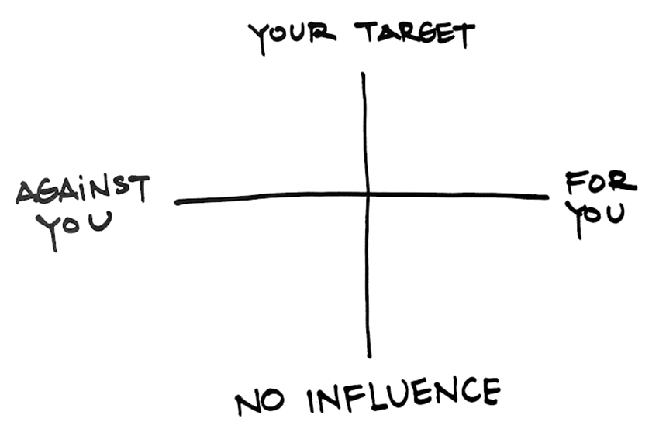
You need to place post-its or write names on the two axes of your Power Map.
- If someone is very powerful and supports your campaign, they’d go in the top right.
- If they’re very powerful and oppose your campaign they’d go on the top left.
- If they have less power but support you, they go in the bottom right.
- If they have less power and don’t support you, they go in the bottom left.
Once it’s done talk to the people you’re working with to figure out if you need to rethink your objectives, or campaign target.
Remember – if you talk to someone and change their mind or get them on your side – you can move them from one place on the Power Map to another.
Choose your tactics
This can be the fun bit – picking the things you’ll do to make change happen — the tactics.
One big mistake many people make when campaigning is when they start by picking their tactics, before they figure out the problem, goal and objectives. The problem with this is you’ll often waste lots of your time and energy doing a tactic that isn’t linked to fixing the problem you care about.
Tactics can be anything from starting a petition, organising a meeting (virtual/online) or getting the campaign in your local newspaper.
Pick your tactics is by figuring out which tactics help to achieve your objective. Here’s an example:
Example Objective: “A road crossing should be built outside school”
Possible Tactics
- Tactic 1 – Petition. Start an online petition and send it around all your local friends asking them to sign the petition to join the campaign. Or start a paper petition (as well as online) and pass it around asking people to join the campaign by signing the petition.
- Tactic 2 – Demonstration. Hold a demonstration or an event and ask the local newspaper to come along, or get some photographs or video and send them to the newspaper and post them online.
- Tactic 3 – Get the support of local organisations that might share or support your objective - then ask them to join the campaign
- Tactic 4 – Meeting with the campaign target. Present the petition to the person at the council who has the power to get a road crossing built. This person is your “campaign target” or “decision maker”. Before you do this you will need to do some research and work out who this person is.
Choose tactics that help you achieve your objectives and stay focussed on that. It’s fine to change tactic – if you’ve tried something and it does not work.
But don’t overstretch yourself by doing loads of tactics all at once.
Spreading the word – so you have lots of supporters who will help you win!
Campaigns are never won by one person working alone.
To win your campaign you’ll need to bring together a group of people who work with you to plan your campaign, and then attract some campaign supporters.
Supporters are important – as they’ll show your campaign target that this is a problem lots of people care about. This not only gives you more power – but also means that you don’t have all the pressure on yourself.
Many campaigns start with a petition. It allows you to explain to the world what you’re doing, and enables the public to show their support quickly and easily. Ultimately petitions are about building and showing your power — by showing how many people care about your campaign.

But always remember that a petition alone is not a campaign
A campaign should build over time using a variety of tactics — a petition is just one of them. Some campaigners start petitions online if something is of national or international interest.
For a local campaign you are best starting a petition to collect signatures on paper.
Building Pressure
Keep going – so your campaign target feels the pressure
One of the key decisions a campaign target will make is: “Can I ignore this campaign?”
When some campaigns start the target (who makes the decisions) may look at what you’re doing and think “Yes, I can ignore this, it’s not a big deal”.
Or they may think, “I didn’t know that’s the way people feel, I will find out more or take action!”
Your challenge is to change their mind by planning for your campaign to keep going.
Then as your campaign grows your campaign target will realise that your campaign isn’t going to go away.

