Updating your Bright Stars Blog
- Please navigate to our new website’s login page: https://www.cforlp.org.uk/my-account/?access=login

- Login with the details provided (via email)
- You will now need to navigate to the members area on the left hand side. Scroll down until you see your schools page like below:

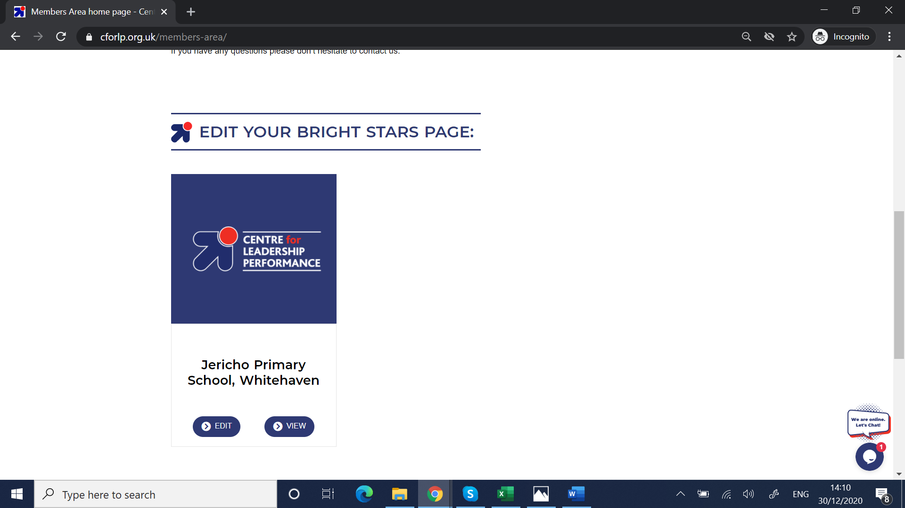

- Click edit. A box will appear below this button (see image below). You can now edit your blog. Please post your first entry at the top and then the next below and so on.
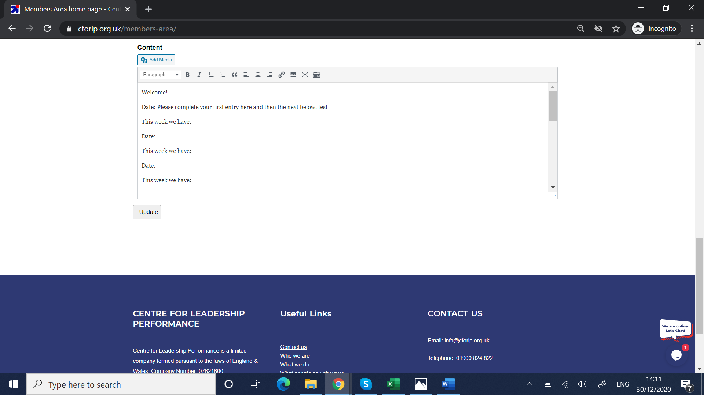

- If you would like to add any photos or videos, please click the add media button- a new window will pop up like below: you can drag and drop video into this box.
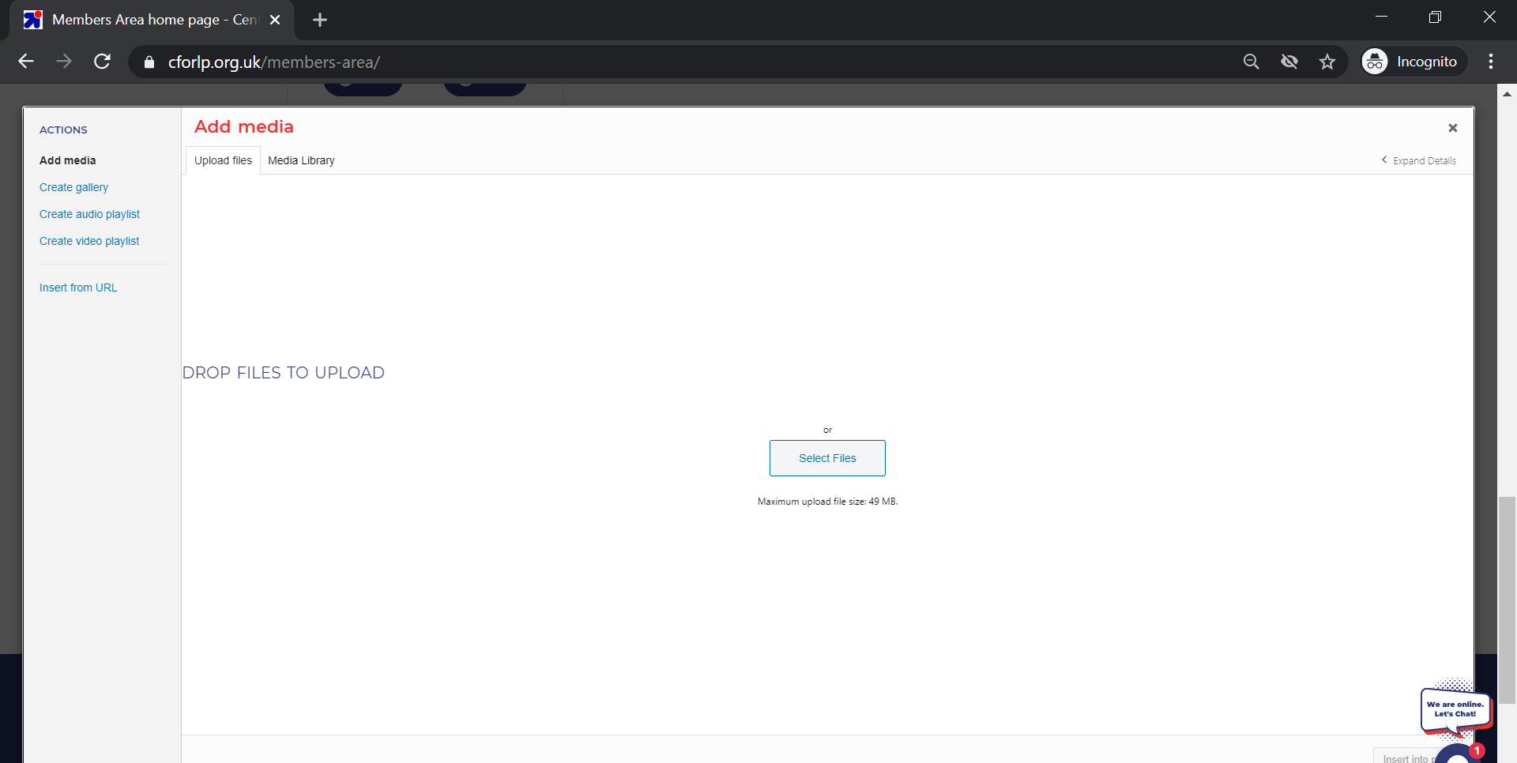

- Click insert into page at bottom right.
- When you have finished updating your blog, click update below the text box.
- You can view your changes on the main blog by clicking view or navigating to: https://www.cforlp.org.uk/bright-stars/primary/

If you have any technical problems, please don’t hesitate to send us a message in our chat function in the bottom right of any page of our website or send an email to sarah.pearce@cforlp.org.uk. If you have any questions about the Bright Stars programme, please email Claire.johnson@cforlp.org.uk .

