Autumn/Winter 2023
Winners

Most profitable social enterprise
Winning School: Ewanrigg Junior School
Business Mentor: North Lakes Hotel & Spa part of Daniel Thwaites
Sponsor: Allerdale GDF
Social Enterprise: Ewanrigg Junior School "Ewanrigg Winter Warmer Project," aimed to address winter difficulties in the community. The team initiated a hot chocolate station, Christmas cards sale, and a successful "Pies, Peas, and Bingo Night," raising funds for their winter warmer packs. They also organised a Christmas event, including a coat exchange. The result was the creation and distribution of Winter Warmer packs to those in need, bringing joy and warmth to the local community.
Reason for win: The total profit totalled to an impressive £2066.76. 100% of their profit has been spent on supplies for winter warmer packs for the elderly and vulnerable in their community and the community centre identified those most in need to receive a pack.

Best demonstration of being a great communicator
Winning School: Derwent Vale Primary and Nursery School
Business Mentor: Whitehaven Harbour Youth Project
Sponsor: Allerdale GDF
Social Enterprise: Derwent Vale Primary and Nursery School, “Whitehaven Harbour Project," planned and executed events, such as a festive bake sale and Christmas games. The highlight was the Christmas Cosy Day where various activities and stalls were set up, including selling hot dogs, hot chocolate, Christmas crafts, handmade jewellery, and popcorn. The students created a mini-Christmas market within the school, offering products and treats to their fellow students. The event aimed to bring a sense of warmth and festivity to the school community.
Reason for win: They had to arrange their events around an already busy school diary, communicating with their senior leaders to organise this. The pupils also learn how to communicate with younger pupils respectfully.

Best marketing idea
Winning School: Broughton Moor Primary School
Business Mentor: No Name Travel
Sponsor: Allerdale GDF
Social Enterprise: Broughton Moor Primary School ‘Tradimals’ created unique wildlife-themed trading cards.
Reason for win: The primary school thought carefully about their USP and they created a catchy theme tune. The pupils also thought about different audiences and they posted on their internal social media platform. They developed a unique product that would sell well.

Best example of leadership
Winning School: Seaton St Paul's C of E Junior School (Class 5O)
Business Mentor: University of Cumbria Business Student Faye Holiday and volunteer Angela Schinzel
Sponsor: Allerdale GDF
Social Enterprise: Class 5O of Seaton St Paul's C of E Junior School, "5O Chocolate" sold hot chocolate cones at Dunmail Park.
Reason for win: The pupils used their initiative by adding a customer service team who made sure that everyone had ‘beautiful smiles on their faces’, an important element of leadership!

Best example of technology use
Winning School: Valley Primary School and Nursery
Business Mentor: Barclays Eagle Labs
Sponsor: Nuclear Waste Services
Social Enterprise: Valley Primary School's Team 'Top Notch' Initially focused on creating products for the school Christmas Fayre, intending to raise funds for the school food bank. They explored environmentally friendly options, such as biodegradable products.
Reason for win: They used social media, created engaging videos of their progress which they shared on social media and utilised a 3D printer to create Christmas decorations. They also made sure to use branding throughout their marketing efforts.

Most positive long-term impact
Winning School: Moor Row Community Primary School
Business Mentor & Sponsor: Bechtel Cavendish Nuclear Solutions
Social Enterprise: Moor Row Community Primary School's "Leafy Habitats" aimed to enhance biodiversity by obtaining and selling trees. The team also created and sold bird feeders, aiming to contribute to environmental conservation and community engagement.
Reason for win: The pupils made bird feeders and planted trees to help their local environment. They enjoyed the idea that in the future they can take ‘their children and grandchildren’ to see them.

Best social enterprise business idea
Winning School: Broughton Primary School
Business Mentor: The Vicky Business Centre
Sponsor: Allerdale GDF
Social Enterprise: Broughton Primary School's Team BPS, made seasonal fun accessible to families facing financial challenges. They sold a variety of seasonal products, including craft packs, sweet treats, clay bead bracelets, and Christmas decorations. They also introduced the concept of "Elfridges," where children could choose, wrap, and label presents for family and friends. Additionally, they sold cookies and biscuits at their Christmas Fayre. They plan to use the 50% of the profits to continue ensuring families can enjoy seasonal activities without the financial burden. Their ideas are- Easter eggs, easter treats, workshops to make bonnets. They said "All pressures a family can face, we want to ensure no family in our school feel this as we can provide the opportunities due to our fund raising through our Bright Stars project.” The school are reinvesting 50% of their profits back into their community.
Reason for win: They are reinvesting 50% of the profits to continue ensuring families in their school can enjoy seasonal activities without the financial burden beyond just the Bright Stars project and their Elfridges idea was unique and a great use of branding.

Best logo
Winning School: Oughterside Foundation School
Business Mentor: Centre for Leadership Performance
Sponsor: Cumbria Community Foundation
Social Enterprise: Oughterside Foundation School "The Oughterside Stars," planned a pensioners coffee morning and a Christmas fair, where they made and sold festive items like reindeer food, hot chocolate, and bird feeders.
Reason for win: They designed a colourful logo which described their business and also incorporates their school logo.
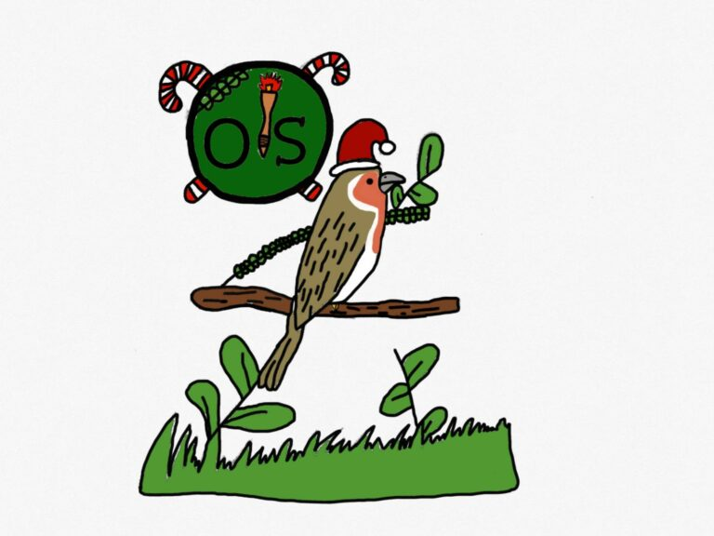

Best example of staying positive/resilient
Winning School: Kingmoor Nursery and Infant School
Business Mentor: Bell Group
Sponsor: Cumbria Community Foundation
Social Enterprise: Kingmoor Nursery and Infant School organised a Christmas event, including a craft competition, a Christmas Window Wander.
Reason for win: Unfortunate circumstances lead to their business mentor being unable to continue supporting the school from week 2 onwards. The pupils, however, did not let that get to them, they powered on a created a great social enterprise and most importantly had fun!

Best example of community engagement
Winning School: St Cuthbert's School
Business Mentor: Twoey
Sponsor: Cumbria Community Foundation
Social Enterprise: 'St. Cuthbert's Nursery' made Fizzing Bath Crumble, and sold their product at local events, including a food bank and a café, demonstrating creative presentations like cones and baubles.
Reason for win: The children went into their community to sell their bath salts including the local Co-op, a local food bank and a café. They learnt how to engage with customers, greeting people with a smile and a hello.

Best example of teamwork and collaboration
Winning School: Kirkbride Primary School
Business Mentor: Diff-Ability CIC
Sponsor: Cumbria Community Foundation
Social Enterprise: The social enterprise undertaken by Kirkbride Primary School was named "Team Kirkbride". The pupils organised a Festive Fair, where they created and sold handmade crafts including candle jars, cork reindeers, bracelets, and hot chocolate cone mixes.
Reason for win: The pupils worked together as a team to create their products to sell. They had a vote to choose the best logo. They all had a different role and they decided on their roles by finding out pupils’ interests and skills and picking the role that suited them the best e.g. creative pupils helped with the marketing. They all worked together and listened to each other’s tips. For example some of the pupils knew how to make bracelets and taught the pupils who didn’t how to.

Best business plan
Winning School: Thursby Primary School
Business Mentor: Marsh Commercial
Sponsor: Cumbria Community Foundation
Social Enterprise: Thursby Primary School's "Sprinkle of Joy" created salt-dough and wool decorations, Santa stones, and organised events like a coffee morning and carol singing.
Reason for win: The school had a detailed and clear business plan and followed it through. They considered what they needed, what help they would need, their finances, their customer demographic, where to advertise, a mission statement and job roles.

Congratulations to everyone involved!!
To read what all the schools got up to, click here
To view all the fabulous school videos, click here

